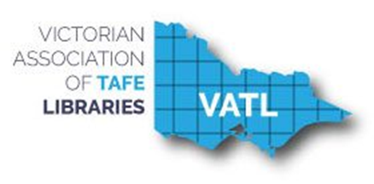

VATL

Annual Report   
2017

Table of Contents

**EXECUTIVE REPORTS** 3

President’s Report 3

VATL Executive Members 2017 4

Treasurer’s Report 5

2017 VATL Finances 6

**SUBSIDIARY GROUP REPORTS** 8

Cataloguing Acquisitions Serials and Systems (CASS) 8

Liaison, Information & Training (LIT) 9

VET Libraries Advisory Committee 10

**MEMBER LIBRARY REPORTS** 12

Bendigo Kangan Institute 12

Box Hill Institute 13

Chisholm Institute 14

Federation Training…………………………………………………………………..…15

Federation University 16

The Gordon 17

Goulburn Ovens Institute of TAFE (GOTAFE) 18

Holmesglen Institute 19

Melbourne Polytechnic………………………………………………………………....20

RMIT University 21

South West Institute of TAFE 22

Sunraysia Institute of TAFE (SuniTAFE) 24

Swinburne University of Technology 25

Victoria University 27

William Angliss Institute 29

Wodonga TAFE..................................................................................................... 30



# **EXECUTIVE REPORTS**

## President’s Report

Zita Youens retired at the end of 2017. In her absence Leanne Meere (Secretary) will write the the President’s report for 2017 in her place. The Executive Committee would like to express their gratitude to her for all the time and work she invested in her role as the President of VATL. I’m sure she would like to take this opportunity to thank the Executive Committee for their continuing support and contribution.

The 2017 Executive Committee consisted of: Leanne Meere (Swinburne University of Technology) as Secretary; Jill Perkins (Box Hill Institute) as Treasurer; Colin Sutherland (Chisholm Institute) as CASS Convenor; Michael Huang (Melbourne Polytechnic) as LIT Convenor, and Brenda Burr (Wodonga TAFE) as VLAC representative with ALIA.

Once again CASS group organised and held successful PD days. Included in the yearly program was a online remote access workshop which was well attended, including our regional libraries. Well done team.

Unfortunately the timing and work commitments meant that LIT did not have any workshops or seminars. Michael is looking forward to putting together a workshop on repositories early next year.

It seems the themes for 2017 can be summed up using the following words:

* refurbishments
* Relocations
* revitalisation of space
* weeding
* increasing the presence of online resources and online presence

Leanne Meere

VATL Secretary

Swinburne University of Technology

## VATL Executive Members 2017

|  |  |
| --- | --- |
| **President:** | Zita Youens  Manager, Learning Commons Holmesglen |
| **Secretary:** | Leanne Meere Liaison Librarian Swinburne University of Technology |
| **Treasurer:** | Jill Perkins Information Services Librarian Liaison Librarian – Trades; Hair & Beauty and Floristry Box Hill Institute |
| **CASS Convenor**: | Lynette Stanyer Technology Co-ordinator Library & Learning Centre Bendigo TAFE and Kangan Institute |
|  |  |
| **LIT Convenor** | Naomi Fergusson Branch Manager – Waverley Learning Commons Holmesglen Institute of TAFE |
| **VLAC VATL Rep** | Brenda Burr Manager, TAFE Library Services and Copyright Officer Wodonga TAFE |

## Treasurer’s Report

Jill Perkins

Box Hill Institute

Treasurer

The treasurer’s role in 2017 was initially held by Sharon Stewart, with Jill Perkins taking the role over late in the year.

VATL had an opening balance at 17 December 2016 of $4,632.43 and at December 2, 2017 had a closing balance $8,297.09.

The main expenditure during the year was in support of a local professional development activity arranged by the special interest group CASS. No LIT events were run this year, reducing costs. Other expenditure included website hosting fees, bank fees, and regulatory payments.

The main income for the year was annual membership fees. Additional income streams were a $500 sponsorship of lunch costs for the CASS training day by Ex-Libris; and $400 from the VET Development Centre towards domain hosting charges ($200 p.a. for the next two years). No changes to annual membership fees are anticipated for 2018.

Further financial details are included in the VATL Annual Summary at the end of this report.

## 2017 VATL Finances

|  |  |  |  |
| --- | --- | --- | --- |
| Opening balance 17/12/2016 | $4,632.00 |  |  |
|  | $AMT |  | $AMT |
| **Jan. 2017 Income** |  | **Jan. 2017 Expenditure** |  |
| Nil |  | CBA Merchant fee | $11.00 |
|  |  | CommBiz Fees | $16.00 |
|  |  | Consumer Affairs (VATL annual statement  Cheque 000459 | $55.80 |
|  |  |  |  |
| **Feb. 2017 Income** |  | **Feb. 2017 Expenditure** |  |
| Credit interest |  | CBA Merchant Fee | $11.00 |
|  |  | Commbiz Fee Transaction | $5.50 |
|  |  |  |  |
| **Mar. 2017 Income** |  | **Mar. 2017 Expenditure** |  |
| Membership Fees | $2,600.00 | CBA Merchant Fee | $11.00 |
|  |  | Commbiz Fee Transaction | $5.50 |
|  |  |  |  |
| **Apr. 2017 Income** |  | **Apr. 2017 Expenditure** |  |
| Membership Fees | $1,195.00 | CBA Merchant Fee | $71.04 |
|  |  | Commbiz Fee Transaction | $5.50 |
|  |  |  |  |
|  |  |  |  |
| **May. 2017 Income** |  | **May. 2017 Expenditure** |  |
| Membership Fees | $750.00 | CBA Merchant Fee | $12.59 |
|  |  | Commbiz Fee Transaction | $5.50 |
|  |  | CASS Workshop gifts | $83.35 |
|  |  |  |  |
| **Jun. 2017 Income** |  | **Jun. 2017 Expenditure** |  |
| ExLibris sponsorship of CASS lunch | $500.00 | CBA Merchant Fee | $11.00 |
|  |  | Commbiz Fee Transaction | $6.05 |
|  |  | CASS workshop catering | $1,319.00 |
|  |  |  |  |
| **Jul. 2017 Income** |  | **Jul. 2017 Expenditure** |  |
|  |  | CBA Merchant Fee | $15.70 |
|  |  | Commbiz Fees | $6.05 |
|  |  |  |  |
| **Aug. 2017 Income** |  | **Aug. 2017 Expenditure** |  |
|  |  | CBA Merchant Fee | $11.00 |
|  |  | Commbiz Fee Transaction | $5.50 |
|  |  | Uber web hosting charges (2 years from 26/7/17) | $598.80 |
|  |  |  |  |
| **Sep. 2017 Income** |  | **Sep. 2017 Expenditure** |  |
|  |  | CBA Merchant Fee | $11.00 |
|  |  | Commbiz Fee Transaction | $5.78 |
|  |  | Uber web hosting charges | $179.40 |
|  |  |  |  |
| **Oct. 2017 Income** |  | **Oct. 2017 Income** |  |
|  |  | CBA Merchant Fee | $39.00 |
|  |  | Commbiz Fee Transaction | $5.78 |
|  |  |  |  |
| **Nov. 2017 Income** |  | **Nov. 2017 Expenditure** |  |
| VDC funding of web hosting charges ($200 p.a. for 2 years) | $400.00 | CBA Merchant Fee | $11.00 |
|  |  | Commbiz Fee Transaction | $5.50 |
|  |  |  |  |
| **Dec. 2017 Income** |  | **Dec. 2017 Expenditure** |  |
|  |  | CBA Merchant Fee | $11.00 |
|  |  | Commbiz Fee Transaction |  |
|  |  |  |  |
| Total income | $6,200.00 | Total expenditure to 2/12/17 | $2,535.34 |
| Closing balance: 2/12/17 |  |  | $8,297.09 |
|  |  |  |  |

**ANNUAL STATEMENT SUMMARY 2017**

|  |  |  |  |
| --- | --- | --- | --- |
| ANNUAL STATEMENT SUMMARY |  |  |  |
|  |  |  |  |
| **Income** |  | **Expenditure** |  |
| Memberships | $5,300.00 | Bank fees/charges | $298.99 |
| ExLibris sponsorship of CASS lunch | $500.00 | Workshop/meeting expenses | $1,402.35 |
| VDC funding of web hosting charges | $400.00 | Subscriptions & fees | $834.00 |
|  |  |  |  |
|  |  |  |  |
|  | **$6,200.00** |  | **$2,535.34** |
|  |  |  |  |



# **SUBSIDIARY GROUP REPORTS**

## Cataloguing Acquisitions Serials and Systems (CASS)

Colin Sutherland

Chisholm

CASS Workshop I

Technology - Mobile Apps & More...

Held at Kangan Institute – Docklands Campus

Friday 19 May 2017 (55 attendees)

• Brightspace - Case Study - Holmesglen LMS – Presented by Nicole Little

• Alfresco Overview & Parashift Support – Presented by Henri Guillaume

• Case Study – Chisholm LMS “Share” Project - Presented by Steve Bergen

• Turnitin - Product Overview & Integration - Presented by Anna Borek

• Lunch - Kindly Sponsored by ExLibris

• Easy Cite – RMIT Referencing Tool – Presented by Frank Ponte

• ExLibris CampusM (campus wide mobile app) demonstration - Presented by Erin Pryor

• FE Technology Boopsie (Library app) demonstration - Presented by Benjamin Audibert

• Orientation Games App - La Trobe University Library - Overview & demonstration – Presented by Ian Rossiter

CASS Workshop II

Regional TAFE Showcase, Achievements & Challenges - Bluejeans online workshop

Hosted by Kangan Institute - Lynette Stanyer

Thursday 27 July 2017 (15 attendees)

• Federation Training Library – Presented by Ruth Downs

• SuniTAFE Library - Presented by Stewart Brown

• South West TAFE Library – (no presenter)

• Wodonga TAFE - Presented by Brenda Burr

• Bendigo TAFE Library - Presented by Kay Smith

• Goulburn Ovens Institute of TAFE - Presented by Anne Ritter

• Round Table Discussion, Ask your colleagues anything!

Colin Sutherland Chisholm Institute (Convenor)

Kathleen Dauksza Melbourne Polytechnic

Krystyna Derwinska RMIT University

Ruth Downs Federation Training

Lynette Stanyer Kangan Institute

## Liaison, Information & Training (LIT)

Michael Huang

Melbourne Polytechnic

Unfortunately due to time constraints, no workshops were run in 2017. However, the LIT committee is planning a forum on institutional repositories for TAFE libraries to be held in 2018.

Institutional repositories are common among research universities but have yet to make a similar impact on the VET sector. A few TAFEs have set up repositories, for example the Holmesglen Institutional Repository.

The intention of institutional repositories is to capture the entire academic output of an institution. Any teachers, students or support staff who publish a paper in a peer reviewed journal can deposit a copy in the institutional repository. Repositories are indexed by major search engines such as Google Scholar.

Repositories promote authors and their institutions by making their papers widely and freely available. They are also part of the open access movement which seeks to make publicly-funded research freely available to the public, instead of being held behind a paywall by commercial interests.

Unfortunately my current responsibilities will make it difficult for me personally to organise future events. But I would welcome any interested VATL members to join or lead the LIT committee to contribute to the professional development of the VET library sector.

## VET Libraries Advisory Committee

Brenda Burr

Wodonga TAFE

VET Libraries Advisory Committee (VLAC)

Wednesday 6th December, 2017

This has been my second year as VLAC representative on the VATL Executive. Membership of VLAC includes Debra Hannan (Co-Chair, Tas.), Ruth Barnett (WA), Beatriz Aroche (Co-Chair, NSW), Jaci Ganendran (ACT), Angela Orth (Qld), Mary Carroll (NSW), Vicki McDonald and Sue McKerracher (ALIA). At the last meeting it was reported that Jane Garner would no longer be participating. Meetings are held bi-monthly by teleconference. I have participated in all five meetings scheduled this year to date.

ALIA PD Scheme VET specialisation

The main focus of the committee in 2017 has been developing a VET specialisation for the ALIA PD scheme. The ALIA PD scheme is available to personal professional members (Associate or Library Technician) of ALIA. Existing specialisations include Research/Academic, Health, Public Library, Schools and Government.

In developing the VET specialisation scheme the committee worked with Judy Brooker, ALIA’s Director of Learning. The existing Health and Research/Academic specialisations were used as a starting point and adapted by the committee for the VET perspective.

The VET specialisation competencies were identified as:

1. Understand the VET Libraries environment and the policies, issues and trends that impact on that environment
2. Understand and apply the principles and practices related to information literacy, digital literacy and provision of information services to meet the needs of VET users
3. Understand and facilitate the management of VET Library resources in a broad range of formats
4. Know and understand the application of leadership principles, management, finance, marketing, and promotion
5. Understand and use technology and systems to manage all forms of information
6. Understand curricular design and instruction and have the ability to teach methods on how to access, organize and use information
7. Understand the learning and information needs of VET teachers, trainers and students and the industry specific and subject specialist matter relevant to the VET Institution
8. Maintain currency of professional knowledge and practice, including copyright.
9. Manage professional relationships with teachers, trainers, students and support staff, and communicate information and resources to a range of users

The next task was to identify a VET specialisation Skills Audit, or checklist, to help members of the PD scheme identify the gaps in their knowledge and provide guidance for choosing the most appropriate continuing professional development activities.

The current DRAFT of the skills audit is attached to this report.

ALIA PD scheme starts from the 1st July each year. If the VET specialisation can be launched in December 2017 as planned, individuals who wish to do so can backdate their participation in the scheme to 1st July, 2017.

SAI Global and access to Standards

The other issue frequently discussed by the VLAC committee was the widespread dissatisfaction with the inconsistent and restrictive business practices of SAI Global which were of significant concern for the VET training sector. It was considered timely to raise our concerns as SAI Global’s publishing agreement is due to expire in 2018 and Standards Australia has launched an open process seeking market terms for distribution.

Committee members were asked to source evidence, and examples, regarding lack of access, pricing and how SAI Global business practices are impacting on the ability of VET Institutes and Libraries to provide training, including consumer rights issues and fair-trading implications, for ALIA to advocate on behalf of VET libraries. VATL Executive were invited to submit their responses. At this time we are waiting to hear what action ALIA may take to advocate on the VET library sector’s behalf.



# **MEMBER LIBRARY REPORTS**

## Bendigo Kangan Institute

No report

## Box Hill Institute

2017 was a year of moves for the Box Hill Institute Library, with every one of our branches affected by physical relocations in some way.

In February, the Fashion, Graphic Design & Art collections moved from our Whitehorse Library to a new library located within our Nelson Rd building, a few hundred metres down the road in Box Hill.

In April, the interim library at our Lilydale Lakeside campus moved into its permanent home in newly refurbished premises. The library became known as the Lilydale Lakeside Campus Academic Library to distinguish it from the Lilydale branch of Eastern Regional Libraries, which is located in the same building.

Also in April, our City Campus Library moved from a Degraves Street location into the main CAE building on Flinders Lane, above the Melbourne Library Service’s City Library.

The end of September saw our final move of the year, with our Whitehorse Library permanently closing and the remainder of its collections distributed to our new Nelson Library and the existing Elgar Library.

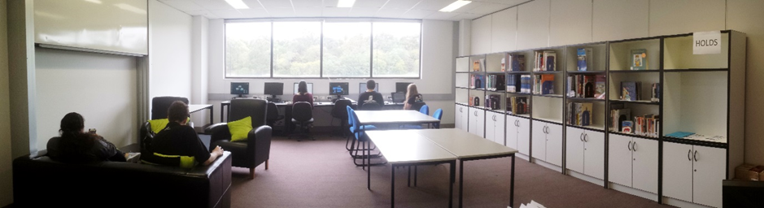

## Chisholm Institute

Works were completed on the demolition of two existing buildings at the Frankston campus to make way for the construction of a new three storey building which will house the new Frankston Campus Library and Hub. The building will also contain the teaching departments of Health, Wellness, Early Childhood and Community Services.

The Institute introduced a Share Library, a repository used to manage teaching resources which teaching departments can use within their Moodle sites. Our Research & Academic Librarians and Copyright Advisor were given access to check all uploaded documents for copyright compliance before they are included in the Share library. These staff have the ability to approve or not approve the materials depending on whether the materials meet copyright compliance specifications.

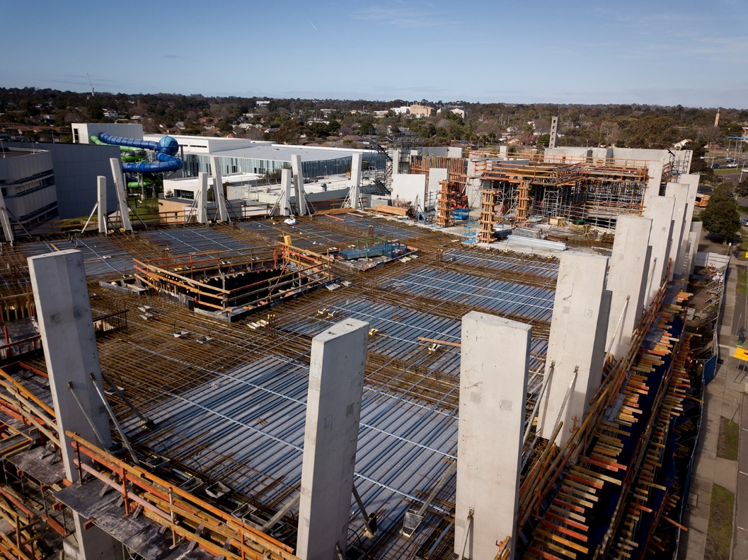

Arial shot of the new building at Frankston

## Federation Training

The restructure of the organisation was finally completed with the appointment of Heads of Department and Program Managers for each major curriculum area.

The Library team now reports to the Manager of eLearning and this relationship is working very well.

After a miserable few years, it was a relief to finally be allocated a reasonable budget.

We revised our collection development policy and with the boost in funding, we were able to really focus on building up parts of the collection that had suffered from neglect and relocate sections of the collection to reflect course changes.

One of our librarians has relocated her home from east to west Gippsland and is now a welcome and regular presence at Warragul and Leongatha libraries which didn’t have any designated staff previously.

Federation University ceased delivering Bachelors in Sport Management & Education at the Traralgon campus of Federation Training.

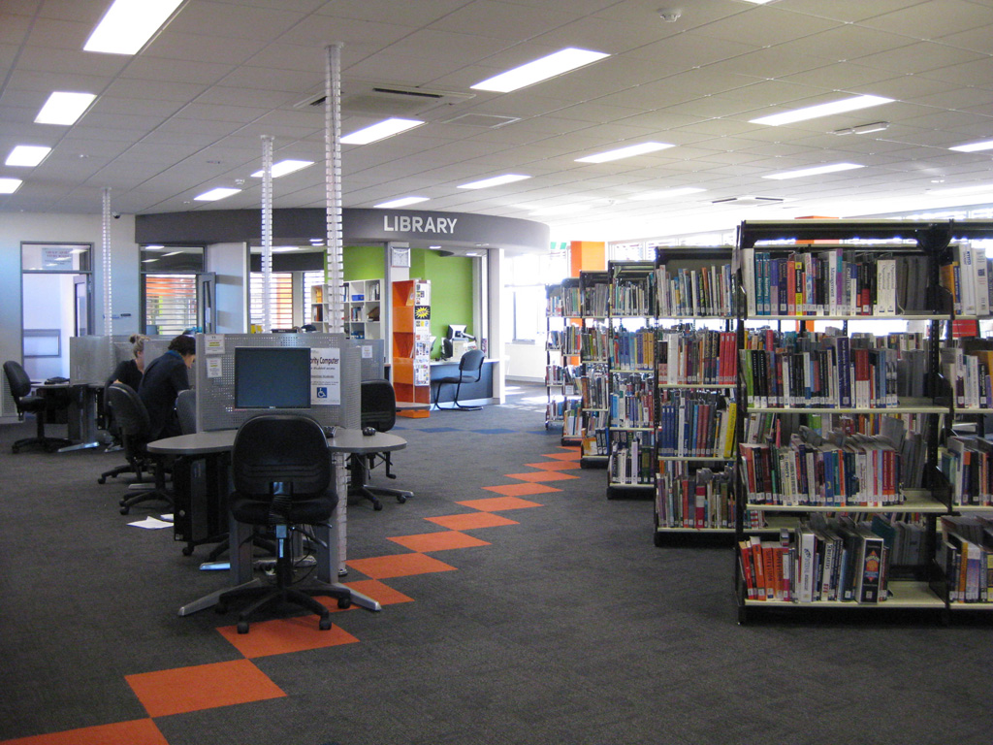



No report



No report

## Goulburn Ovens Institute of TAFE (GOTAFE)

In 2017 GOTAFE acquired extra funding permitting the development of an extensive electronic collection of resources, building upon the strong demand for health and human services, business, and a general overall collection to cover all course areas delivered at GOTAFE.

A key driver for GOTAFE in developing an enhanced electronic collection is due to the increasing demand for academic online resources with access to eBooks doubling

in GOTAFE access from 2016 to 2017. Access to quality electronic resources aims to provide improvements to learning outcomes for GOTAFE students, and provides access wherever and whenever the student requires. Structural changes in June 2017 saw the library move under the leadership of the Education Support Section

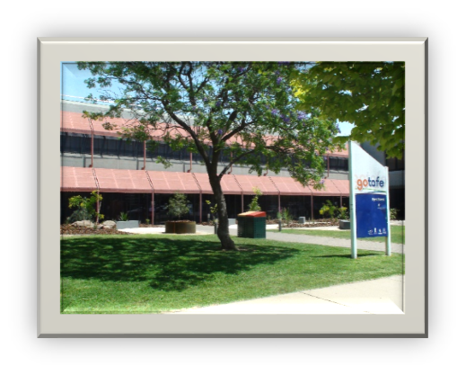

The Education Support team comprises of a team of staff ensuring quality education, digital education access, the library and welfare support.

This blend of Education Support teams has led to a closer alignment with developing goals to support the educational and learning resource needs of the organisation, while also supporting the welfare needs of students at GOTAFE. The team will continue to evolve as GOTAFE finds synergies in practice.

I would also like to take a moment to thank our partner libraries and all of the library staff for their ongoing flexibility in providing a great service to all of our client groups and the support from all of our leadership teams.

Report submitted by Anne Ritter - GOTAFE | Manager, Library Services

## Holmesglen Institute

The major highlights for Holmesglen in 2017 were the completion and opening of the Holmesglen Private Hospital, and the new Moorabbin Learning Commons within a completely new student hub.

The state-of-the-art Holmesglen Private Hospital was opened in January 2017. The hospital also provides clinical practice, as well as teaching and research for nursing and allied health students.

The new student hub incorporates a range of services, of which the Learning Commons was only one part. The other areas include Student enrolments, International Office, Student Services, Security and the student cafeteria.

The new student hub is now the centre of student activities on Moorabbin campus with students enjoying the newly designed spaces in the Moorabbin Learning Commons. The study booths with desktop computers are proving to be most popular with the students.

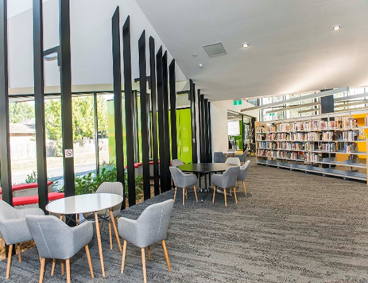 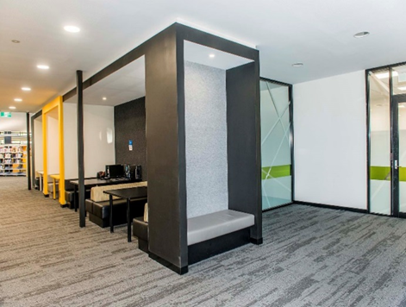

Study booths are very popular with students

Incorporating an indoor garden space

Like every other TAFE institute in Victoria, we have had our ups and downs in relation to courses and enrolments, but overall the Institute has performed well in 2017 and the Learning Commons continues to a make a positive contribution towards student success and satisfaction as borne out in the results from the Insync survey we undertook in 2017.

Sadly, at the end of 2017, Zita Youens, Manager Learning Commons, retired from the position after fourteen and a half years of dedicated service to the Institute. Zita has overseen the transformation of the Learning Commons at Moorabbin and Waverley, and the consolidation of the Learning Commons service on the Chadstone campus during a period of severe budget constraints. We thank Zita for her significant contributions to the Institute.

## Melbourne Polytechnic

The 2017 year saw the Melbourne Polytechnic library service make a number of trans- formative changes, as well as continuing important upgrades to the Library Management System (Spydus 10.1.3 to 10.1.5) and conducting the biennial Insync Customer Service Bench-marking survey. The Insync survey returned strong results enabling us to both plan service enhancements, from the immediacy of extending opening hours through to the more long term goal of reviewing the collection. The service and support provided by our library staff has remained consistently our most valued asset.

The Greensborough library was reopened along with the Greensborough Campus as part of the new innovative community partnership model being created by the State Government and the Institute for the Greensborough community, the area has been well received and is very responsive to the demands of its community. Following the consolidation of the Preston campus library on one floor, library staff seized the opportunity to provide students with work based design practice. As a result the entrance staircase and landing area are now vibrant and welcoming and an excellent example of cooperative practice.

The revitalization of student spaces continued at Preston, thirty year old study corrals were removed, and tables, booths and benches were installed, students needed no invitation to start using the area. At the end of 2017 it was announced that the Learning Skills Assessment Unit would be joining the Student Experience pillar under the management of a new Head of Library and Academic Services, the position would be appointed in 2018.

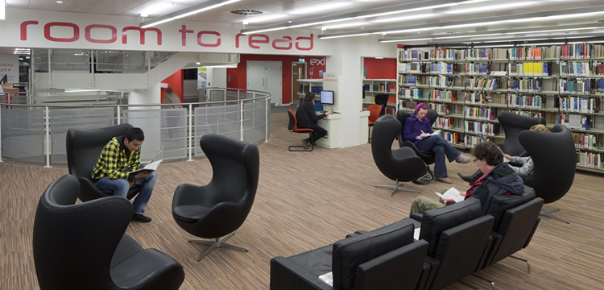

## RMIT University

2017 proved to be another exciting year at RMIT University and for the University Library. We re-established our services and collection in the Swanston Library within the University's New Academic Street precinct. The University Library team grew significantly over the 2016 / 2017 period with a number of groups merging with the Library including the Archives and Information Management team, the Curriculum Services and Study and Learning Centre teams as well as the Student Learning Adviser Mentors ( SLAM's) team. Our new Director David Howard joined the team in 2017 and has been working hard this year to re-imagine and re-define our services and principles...stay tuned for further changes!

Some data for 2017: Visits in person were down 8% from 2016 (1,892,472) with website visits up 7% (1,999,273). Our various satisfaction ratings were all very positive at around 90%. While our total Enquiries were down 6% at 153,668, we saw significant growth in our Ask A Librarian (chat and email) enquiries up 72% and our Liaison enquiries up 19%. Learning support continued to grow in 2017 with 32,164 participants attending Drop In sessions and 19,711 attendees at our organised Information Literacy training.

Our online Learning Lab saw an increase of 23% in page views and our online Maths Ready Quiz had close to 5,000 participants. Our research repository also saw increased activity with 1,358,444 abstracts viewed (up 46%) and 735,890 full text downloads (up 11%). In relation to collections, 88% of our budget was spent on e-resources in 2017 as we continued to pursue an e-preferred model.

E-book usage was up 164% with 5,579,107, e-books accessed. Database usage was up 8% (1,160,670) and streaming media views also continued to grow (687,175). Print usage declined by 22% in 2017 with a total of 209.932 loans.

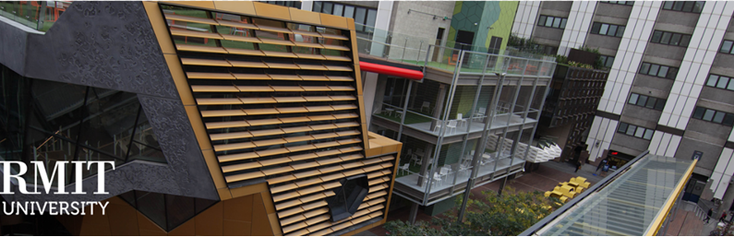

## South West Institute of TAFE

In February, learning support staff began hosting support sessions in the library. This filled a much needed support gap for students to get assistance with topics such as grammar, essay writing, computer skills, numeracy, etc. The service consisted of drop-in support Monday to Friday between 10:00 am and 1:00 pm, with the option for bookings in the afternoon. Even though the Learning Support Unit does not fall under library management, it is well-placed in the library and proves to be extremely popular.

Once again the library hosted its two main events – the Biggest Morning Tea in May and Very Open Day in October.

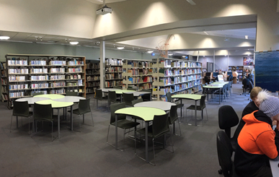

The library continued to struggle with low staffing levels throughout the year, but fortunately we were able to employ a casual library employee from January until April. This employee had previously worked in the library for many years, so was a valuable team member to have on board. The remainder of the year from May to December we relied heavily on the Bookshop Coordinator to help cover the desk. The Student Services Manager, who is not based in the library, also has a regular desk shift on Friday. The other campus libraries are still unstaffed and circulation duties are handled by the Front Office staff at each campus.

Following the purchase of the Ballarat Road Hamilton campus at the end of 2016, the Hamilton campus collection was relocated in early 2017. A proposal was submitted to re-develop the space to create a more welcoming environment, but leasing restrictions put a halt on immediate changes.

An INSYNC Survey was launched in August, which provided us with valuable insight into our library clients’ experience. The results highlighted several positive outcomes, but most of all the appreciation of having helpful and knowledgeable staff. The areas of improvement highlighted were a need for longer opening hours, improvements at the other campus libraries, as well as lack of space for quiet study in the library.

A significant addition to the library included the purchase of Libguides, which greatly increased the time spent liaising with teaching departments. This also gave library staff the opportunity to look closely at the collection, which resulted in a much needed weed in many subject areas.

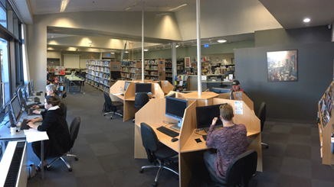

In November, South West TAFE went through a brand refresh, which required the library to rebrand our website and create all new marketing materials and handouts. We chose to utilise Libguides as the platform to build our new website.

## Sunraysia Institute of TAFE (SuniTAFE)

Our staffing has remained stable in 2017, the LRC still has 3.5 TAFE Library members, 1.5 Bookshop staff members, 1 Printroom & 1 La Trobe Staff member. In 2017 the Learning Commons at the Swan Hill Campus entered its second year. The Learning Commons services expanded by providing Printroom Services to Swan Hill campus as well the existing Bookshop and Library services. We had some concern over the increased workload on our Swan Hill staff member, which we are currently in the process of monitoring. The Learning Commons collection has been slowly growing and now sits at around 1250 items.

In 2017 the SuniTAFE Library started a major weeding project. Our plan is to weed up to 30% of the collection based on age and use of resources. With the created space we are planning to turn it in to more quiet study space with access to power for student’s to use.

The Library has also being to trying market our e-resources. We have been doing a lot of individual sessions mainly with staff members showing them what e-resources are available and how they and their students can access it. We have also been pushing with our HR department to make sure that we are a part of the induction process, so that we can catch them early on.

The Library was also part of a program called SuniTAFE Project Placement, where a young person with a disability is given the opportunity to attain work experience and confidence through work placement. Andrew Woods was our Project SuniTAFE placement. He worked 3 hours every day from Monday to Wednesday, doing various jobs in the Library, Bookshop & Printroom. Some of Andrew’s jobs included shelving, shelf reading, mail runs, spiral binding, hole punching and stapling.

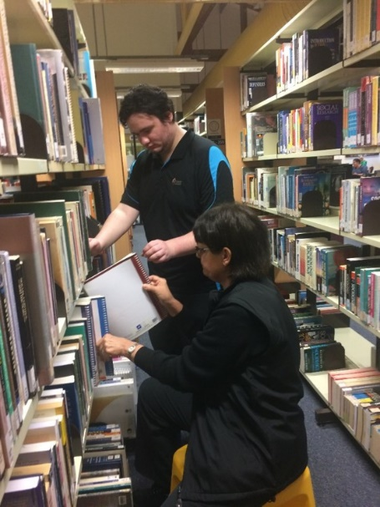 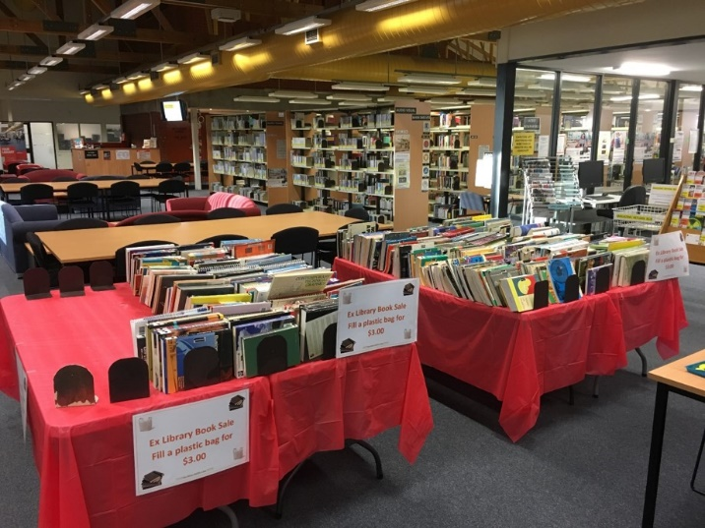

## Swinburne University of Technology

Federation University

Some StudentHQ staff relocated to the Library at the beginning of the year. Both StudentHQ and Library staff completed training in time for the commencement of term/semester one. By September all StudentHQ groups which had been dotted around the Hawthorn campus merged and made their way to the Library space.

In January the Library undertook a large project relocating print books from Hawthorn campus to off-site storage. The criteria for relocating the books was that if the book is available online, the hardcopy would be sent to the off-site storage site. The hardcopies are still discoverable and you are able to request for items to be retrieved from storage. In 2017 91% of all our book titles are now eBook titles and growing. The number of book borrowing is decreasing. In 1992 the Library subscribed to 4,000 print journals. In 2017 we have 2,000 print journals. 98% of our journals collection are online.

All staff are now required to have valid Working with Children cards.

The future of the Library at Swinburne University is changing from being a place where physical resources dominated and quiet study areas were highly regarded are being replaced with online resources and spaces that encourage collaborative learning.

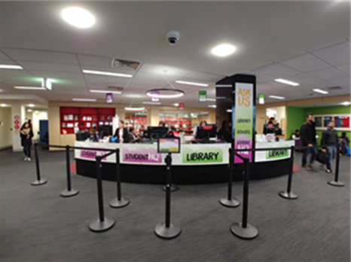

Both Croydon campus and Wantirna campus were refurbished during the Christmas New Year period. Both campuses were up and running in time for the enrolment period.

In November the refurbishment of Level 7 commenced and staff relocated to Level 2 and 3 for the duration of the works.

Building works and the joining of two separate areas of the university meant the year was very disruptive. All staff are coping well with the temporary arrangements and are looking forward to completion of Levels 5 and 6 so they can move back into their space. Level 2 will be totally fitted out and then the next phase which is the refurbishment of Level 1 and Level 3 can begin and hopefully the whole project will be finished early 2019.

## Victoria University

Federation University

Another year has passed and the Library again has some achievements that it needs to celebrate. However, in the first instance, I wish to pass on my thanks to the staff of the Library for the high quality work they do every day: their attention to detail, customer focus, and the way in which they take up new initiatives and make them work.

The highlight of the year 2017 for me was the 2% improvement in the Library Client

Satisfaction Survey score to a 81.4% satisfaction rate overall and our ranking which now puts us squarely in the top 25% of Australian academic libraries in recent years. I believe the high satisfaction is because of three main strategies that we have implemented over the last eight years: a digital strategy that focusses on introducing new digital services and improving the usability of existing digital services, a professional development strategy that concentrates on the digital world where our students live, and a concerted effort to improve the Library’s physical spaces to reflect the way students prefer to study. Plans have now been put in place to improve in those areas the survey identified as needing improvement and actions to implement these plans are now under way.

The University’s First Year College is a first for Australia with the first year units of all

Bachelor degrees delivered one at a time at our Melbourne campuses. There will be more one-on-one time with educators, and a more immersive, collaborative and enriching learning experience. In 2017 the Library made a significant contribution to this work in three main initiatives: Library staff involvement in curriculum and unit design and development, planning for the Learning Hubs at St Albans and Footscray Park Libraries and the development of the Learning Hub system based on CareerHub.

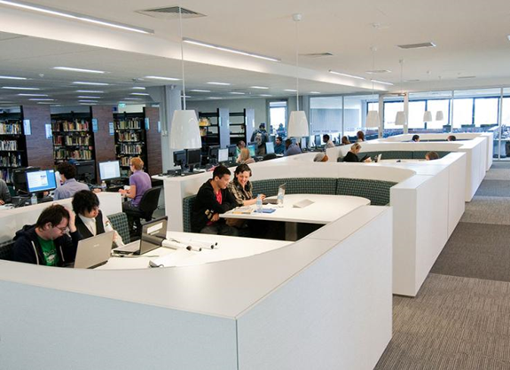

A revolution has been under way in Library Chat where there has been a massive increase in the number of chats from about 70 to 700 per month. Campus Library staff, under the watchful guidance of Jenny Comley, have responded wonderfully to this with no increase in turn-aways despite the massive increase. The figures say it all: in 2017 up to December there was a 264% increase on 2016 and in October a peak of 737 chats for the month.

The reason for the big increase was the development work by Library Digital Services: a pop-up Chat box in the Library search, and a link to Chat from the Learning Management System, VU Collaborate. There were four Library staff recipients of Vice-Chancellor’s (VC) Awards in 2017, with achievements in two awards. Garry Potter, Peter Ring and Jenny Comley received the VC Award for Professional Services and Innovation for Library Extended Opening Hours, and I achieved the VC’s Career Achievement Award for my contributions to student learning, the student experience, and service, engagement and innovation at Victoria University.

Records and Archives Services have also had a busy year starting with the commencement of Sandra Pickett as the new Manager, Records and Archives Services (RAS) on 1st May 2017. Since then there has been an enormous amount of work on a new Electronic Records Management System by RAS staff plus Will and Indu from the Project Management Office, so that the tender documents are ready to go out when the time comes. RAS has made some minor adjustments to its structure and is now ready to undertake the implementation and rollout of a new system and way of managing records.

At the end of 2017 two staff retired from the Library. Peter Ring and Karina McFarlane had extensive careers at the University Library and we wish them all the best for the future.

## William Angliss Institute

Federation University

In 2017, the Learning Resource Centre (LRC) experienced a massive increase in foot traffic through the doors in 2017 of 289,170 people compared to 191,272 in 2016. This increase is partly due to extended opening hours but also due to increased enrolments and improved statistical gathering.

Physical lending of items continued to decline to 8825 compared to 11,720 the year before, but eBook loans nearly doubled from 761 in 2016 to 1498 last year.2017 was also the first proper year of self-check RFID lending which accounted for 47% of book lending. What was especially pleasing was the continued increase is full-text downloads from our database - 52,044 pdf downloads last year compared to 47,099 in 2016 and Ezproxy offsite logins: 32,498 last year compared to 29,761 in 2016. This increase is partly explained by the worldwide decline in physical lending/reading but also factors such as improved EDS searching, Google Scholar linking and webpage functionality.

Some other achievements included the upload to Trove (National Library) of our special collection records and the implementation of APA referencing style as the default style across both HE and VET. In 2017, William Angliss Institute became the first TAFE to have a Masters by Research degree accredited by TESQA. Embedding HE liaison in the Department, additional electronic databases and Endnote classes are a few examples of how the LRC supported the Institute’s push towards self-accrediting status and university of specialisation classification. A continuing challenge for the LRC is to provide expanding information resources and services for its growing HE sector while continuing to support its predominantly VET staff and students.



## Wodonga TAFE

Federation University

* Rapid increase in eBook usage, more than double on previous year.
* New casual seating area and kitchenette in the Library. Gallery system installed for artworks/displays. EZProxy system upgraded to latest version.
* New streaming video collection, Alexander St.
* Trial of Anatomy.TV and consortia price negotiated for Victorian TAFEs.
* Successful copyright audit (Electronic Use) and staff professional development.
* Library & Copyright offerings included in the Professional Development calendar.
* Weed of the serials collection.
* Removal of videocassette collection from public access. Review of titles for replacement.
* Review of Standards collection, consultation with staff prior to renewal.
* Libguides system updated to https.
* Community Service Funding application and reporting.
* Collaboration with Learner Services team to create LibAnalytics tools for collection of data on their client interactions and outreach activities.
* 2017 also saw the retirement of two long serving (20+ years) colleagues from La Trobe University Library.

